Press Release

For Release in Europe, Africa and the Middle East: 24 July 2009

Cat® 328D LCR with tunnel boom boosts productivity on Swiss road project

A dedicated tunnel construction version of the Caterpillar® 328D LCR compact radius excavator is proving highly productive on the A9 Autoroute construction project near Visp, in Switzerland. The first machine of its kind to operate on a Swiss contract, the 328D LCR uses a special dedicated front attachment designed and constructed by German Caterpillar dealer Zeppelin.

The machine offers a powerful, stable yet compact solution for tunnelling contractors. With a rear overhang of just 305mm, providing a tail swing radius of just 1,900mm, the 328D LCR is ideal for the restricted working area within a tunnel construction site. The machine is equipped with the wide tracks from the 330D L conventional crawler excavator, ensuring maximum stability when operating.

In addition the boom mounting has been moved further towards the centre of the machine for the tunnel model, creating an increased lift capacity over the front end compared to a standard 325D L.

The boom itself features a robust box section construction, with high-strength steels, additional supporting struts and reinforced bearings for maximum durability. All pins have hard-chromium plating for optimum protection against wear. Stick digging force is a powerful 134kN, with up to 212kN of bucket digging force available, for maximum penetration in blasted material.

The 328D LCR is also equipped with a heavy duty dozer blade as standard, ensuring outstanding stability when working and providing a useful secondary tool for clearing and levelling within the jobsite.

With two 45 degree tilting mechanisms in the boom construction, that allow the boom to be swung to 45 degrees either side of the machine, the specially-designed attachment linkage provides increased roll back for access to the roof of the tunnel. A Caterpillar CW45S mechanical quick-coupler allows rapid changes between specialist tunnelling attachments, standard Caterpillar buckets and a range of Caterpillar work tools.

The machine is powered by a Caterpillar C7 diesel engine. This six-cylinder EU Stage IIIA diesel motor offers 8 per cent more power than its predecessor, with 190hp (140kW) available at just 1,800rpm. Caterpillar’s ACERT combustion technology results in lower fuel consumption and reduced exhaust emissions. However the tunnel machine is also equipped with a diesel particulate filter as standard, to further cut exhaust gases within the tunnel working.

The 328D LCR is designed for use in transport tunnels of 6-8m in height. With the tunnelling boom in place, the machine has an operating weight of 42,540kg, yet retains a transport height with the tunnel boom of just 3,943mm. Transport width with 600mm track shoes is just 3,190mm.

On the A9 tunnel contract the machine is being used by a consortium of Swiss and Austrian companies working for the canton of Valais’ Routes Nationals Construction (RNC) department. The 31.8km A9 Autoroute construction project will connect Sierre in the west and the town of Brig to the east. The tunnel that is bypassing the town of Visp is just one of a number along the mountainous route.

A fleet of Caterpillar machinery, including 325D, 329D and a couple of 308 excavators, along with a fleet of 972H wheeled loaders, is being used to excavate the blasted material in the two 3.4km tunnel tubes. The 328D LCR is then brought in to finish off the tunnel profile, its compact dimensions and powerful performance providing the ideal combination for the complex task. The machine is being used with hydraulic breakers and buckets to remove the last of the material as the tunnel profile is formed.

Caterpillar dealer Zeppelin developed the tunnel boom specifically for use on the reduced tail swing 328D, originally ordering a number of base machines without booms from the Caterpillar factory. Caterpillar dealers outside of Germany can now order the boom structure directly from Zeppelin, to install onto the 328D upper structure. The excavator can also be equipped with a choice of tunnelling boom and stick or with face shovel work equipment, adding to the versatility of this high performance model.

Tunnel construction is a complex and difficult application for any excavator. Until now, contractors have had little choice in the market, but with the arrival of the 328D LCR, tunnel projects have a machine that has been designed specifically to complete the task. With powerful breakout forces, compact dimensions and a stable working platform, the 328D LCR with tunnel boom is a productive addition to any contractor’s equipment fleet. Zeppelin is also offering a modified 321D LCR excavator with a specific tunnelling arrangement. In addition Avesco, the Swiss Cat dealer, has developed a tunnelling version of the 308 excavator with a swing boom for smaller tunnels.

About Caterpillar
For more than 80 years, Caterpillar Inc. has been building the world’s infrastructure and, in partnership with its worldwide dealer network, is driving positive and sustainable change on every continent. With 2008 sales and revenues of $51.324 billion, Caterpillar is a technology leader and the world’s leading manufacturer of construction and mining equipment, diesel and natural gas engines and industrial gas turbines. More information is available at www.cat.com.

Note to Editors: Caterpillar rolls-out products and services in each of its territories at different time intervals. Although every effort is made to ensure that product information is released only after Caterpillar has received confirmation from our dealer network, our plants, and our marketing subsidiaries that products and services are available in the relevant region, editors are kindly requested to verify with their local dealer for product availability and specifications.

CAT, CATERPILLAR, their respective logos, “Caterpillar Yellow” and the POWER EDGE trade dress, as well as corporate and product identity used herein, are trademarks of Caterpillar and may not be used without permission.

Image Downloads
Click on images below for high res
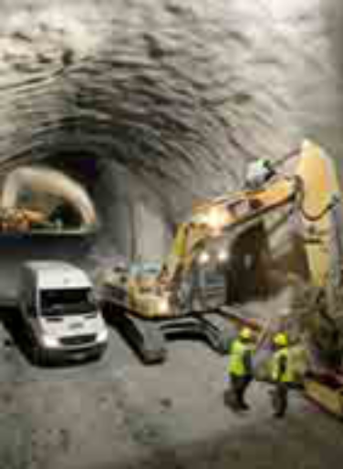
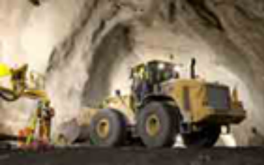
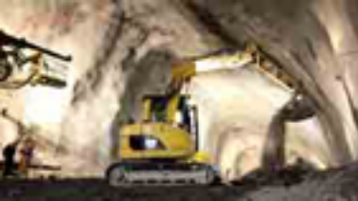
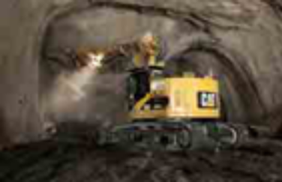
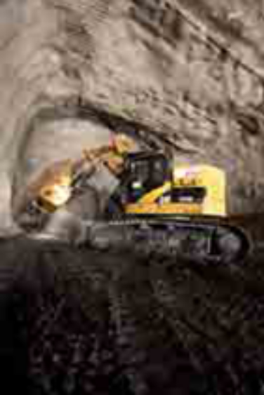
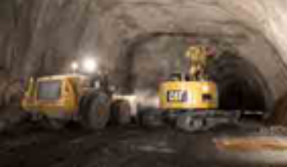
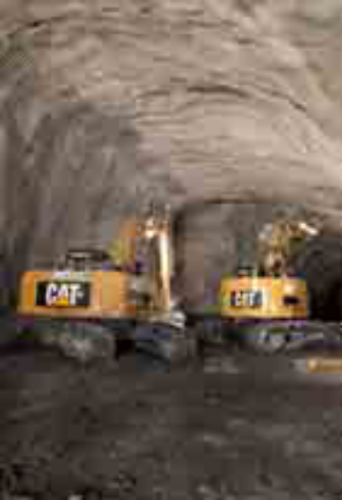

Press Inquiries | Europe, Africa, Middle East:  Mia Karlsson  Tel: +41-22-849-4662  Fax: +41-22-849-9993  Karlsson_Mia@cat.com  Americas:  Sharon Holling Amber Santor  Tel: +1 309-675-8995 Tel: +1 309-675-4693  Fax: +1 309-636-2738 Fax: +1 309-636-2738  Holling_Sharon_L@cat.com Santor_Amber_M@cat.com

